|  |  |
| --- | --- |
| Defect ID | DF001 |
| Tittle | Can’t detect invalid email |
| Test Cases ID | TC_005 |
| Reported Date | 09/11/2022 |
| Priority | High |
| Status | On Progress |
| Descriptions | When users send post requests can’t detect email |
| Expected Result | Response Code 400, Bad Request |
| Actual Result | Response Code 200, Success |
| Report to | Back End |

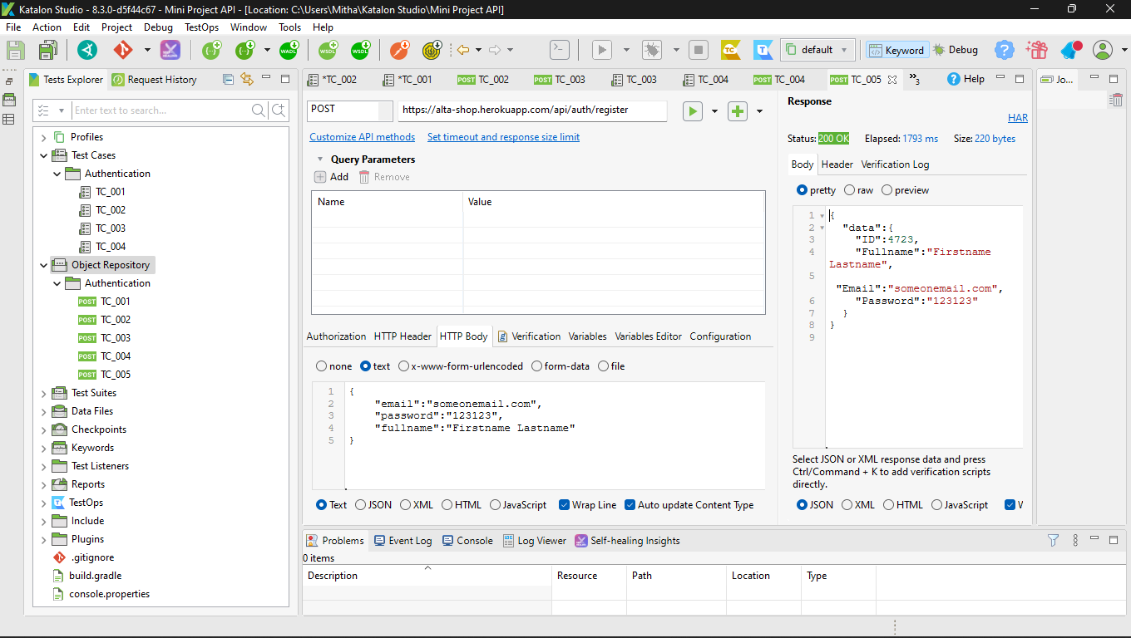

|  |  |
| --- | --- |
| Defect ID | DF002 |
| Tittle | Delete requests with Id product can’t detect |
| Test Cases ID | TC_012 |
| Reported Date | 09/11/2022 |
| Priority | High |
| Status | On Progress |
| Descriptions | When users send Delete requests with Id product can’t detect |
| Expected Result | Response Code 400, Bad Request |
| Actual Result | Response Code 200, Success |
| Report to | Back End |

